**Incline Elementary School: 2023-2024**

**Welcome to Fourth Grade!**

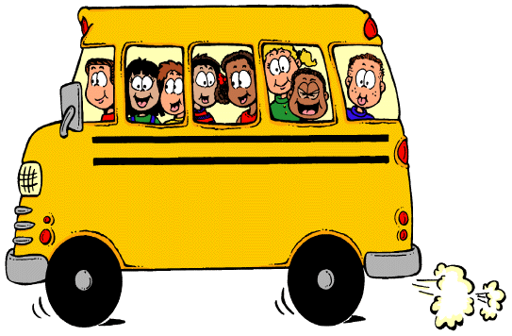

***To Bring to School Every Day***

* Backpack.
* Weather Appropriate Clothing for Outdoor Activities and Appropriate Shoes for Physical Education.
* A Healthy Lunch (unless students are getting hot lunch) and Snack

***Supplies for the First Day of School in Ms. Franklin’s and Mr. Wartman’s:***

***Personal:***

* Earbuds or Headphones
* 1 Composition Book
* Pencil Box with student’s name on it (supplies below can be stored in pencil box with a few personal pencils to start the year off)
  + Set of Colored Pencils
  + Pencil Sharpener with Shavings Container.
  + Good Pair of Scissors.

***Class:***

* Pack of Pencils (#2 Pre-Sharpened Preferred)
* Bottle of White Glue.
* Box of Kleenex.
* Baggies – girls bring quart and boys bring gallon sizes

***School Fees:***

Here is our school fee structure. Please make checks payable to “Incline Elementary School”:

|  |  |  |
| --- | --- | --- |
| Technology Fee | Provides your student with access to classroom technology | $20 |
| Classroom Fee | Provides your student with additional classroom supplies and activities | $40 |
| **Total Fee\*** |  | **$60** |

**\*** Families qualifying for Free and Reduced Meal plans may request school fee waiver. Please come to the main office to complete your FRM forms.

**Have a fantastic school year!**